Chapter 8, Problem 82.

The circuit in Fig. 8.123 is the electrical analog of body functions used in medical schools to study convulsions. The analog is as follows:

C₁ = Volume of fluid in a drug
C₂ = Volume of blood stream in a specified region
R₁ = Resistance in the passage of the drug from the input to the blood stream
R₂ = Resistance of the excretion mechanism, such as kidney, etc.
v₀ = Initial concentration of the drug dosage
v(t) = Percentage of the drug in the blood stream

Find v(t) for t > 0 given that C₁ = 0.5 μF, C₂ = 5 μF, R₁ = 5 MΩ, R₂ = 2.5 MΩ, and v₀ = 60 u(t) V.

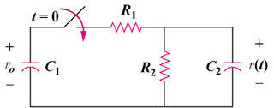

Figure 8.123
For Prob. 8.82.

